**Analysis of Power BI Report and Dashboard for Udemy Courses**

# 1. Introduction

This report examines the demand for specific courses on Udemy and factors that influence this demand. The data used was sourced from Udemy’s website and mobile app. The Power BI report and dashboard provide insights into various aspects of course data, including pricing, number of subscribers, level of difficulty, and revenue. This document outlines the impact of various attributes of the data addressed through the analysis and the insights gained from the data.

# 2. Questions (Problems)

* The relationship between paid and free courses and subscriber count for each subject.
* The total number of subscribers across various subjects
* Total revenue generated from paid courses on Udemy
* The significant difference in subscriber numbers between different course levels, that is, beginner, intermediate and advanced.
* How the difficulty level (beginner, intermediate, advanced) impacts the number of paid subscribers.

# 3. Insights and Analysis

Explain the findings from your analysis. Break this section into subsections based on the questions/problems listed above.

1. Price

An analysis was conducted to determine if the price of the course, whether it is paid or free influenced the number of subscribers. A bar chart revealed that, the number of subscribers that took up a paid course was 39% higher than subscribers who subscribed for free courses. Which shows subscribers do not care much for free courses, which shows priority of value over the price.  
Also, Web development was most popular amongst subscribers. This could be explained by its importance in our digital world today. Web development was followed by Business and Finance courses, with musical instruments having the least subscribers among both paid and free courses.

1. Subject Popularity

Measure which courses or subjects are the most popular amongst subscribers by using the total number of subscribers under each subject.   
With the use of a pie chart, we identified that Web Development was the course with the highest subscribers, with 7.89M, followed by Business Finance (1.87M), Graphic Design (1.06M) and Musical Instruments had 0.85M subscribers. This clearly shows the high demand of Web Development among subscribers on Udemy.

1. Course Difficulty Levels

The analysis indicates that beginner-level courses generally have more subscribers compared to intermediate and advanced-level courses. Intermediate courses follow, while advanced courses have the least number of subscribers.

Beginner courses appeal to a broader audience and are likely more accessible, leading to higher subscriber numbers. Providers might focus on enhancing the appeal of intermediate and advanced courses to increase their reach.

1. This analysis examined subscribers’ engagement across course levels under the various subject.  
   Courses at All Levels had the highest number of subscribers. This could mean the content of the courses took into consideration the skill level of each subscriber and was tailored to address their needs, resulting in satisfaction and a high rate of retention.
2. Beginner level courses also performed well. This could mean subscribers will only proceed from the beginner level if they find value in the course. The lowest was both the Intermediate and Expert Level, which highlights the challenges presented by the course which only committed and motivated subscribers will pursue.  
   Analyzing the various subject based on the course levels, Web Development, has the highest number of subscribers who went through all levels, followed by the beginner level and then intermediate. This was followed by Business Finance, with a few making it to the expert level, and Graphic design and Musical Instruments. The low number of subscribers at Intermediate and Expert Level, especially in Web Development raises questions on the challenges these levels presented.
3. Revenue

The total revenue Udemy made over the period from 2011 – 2017 was approximately 885M. Web Development generated the highest revenue of 631M during the period, followed by Business Finance (124M), Graphic Design (77M) and Musical Instrument (53M) in revenue. The huge disparity of revenue between the subjects raises questions on what is driving the revenue of Web Development and how other subjects can improve.

# 4. Visualizations

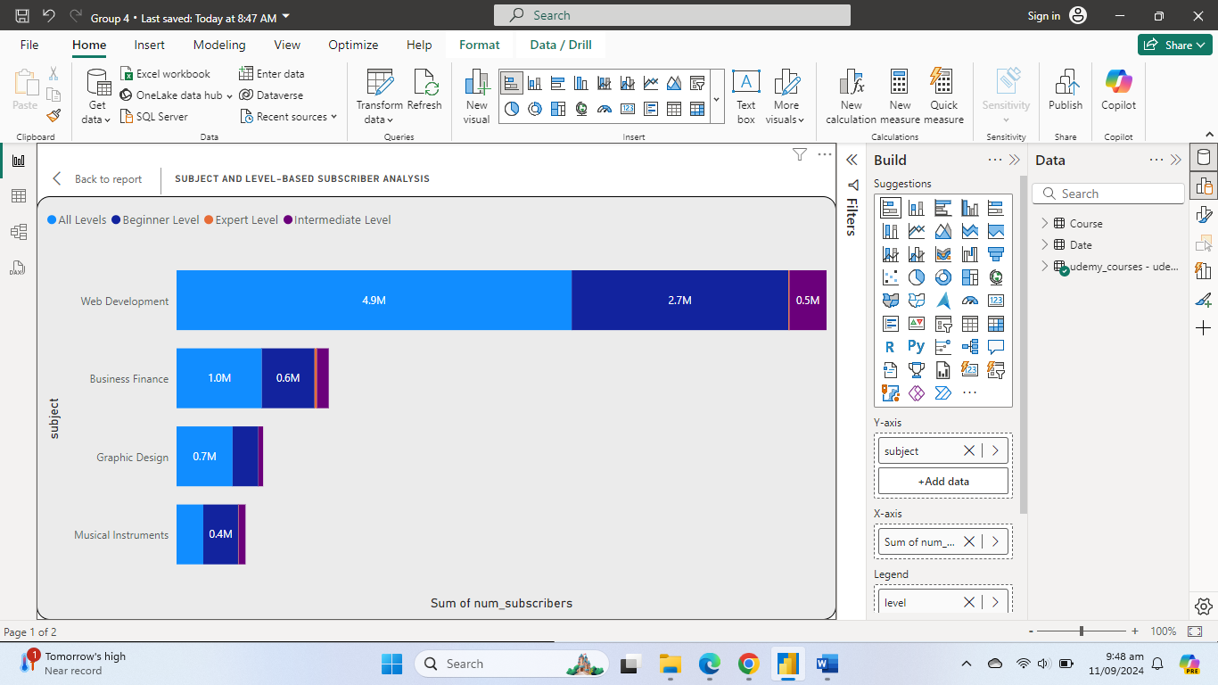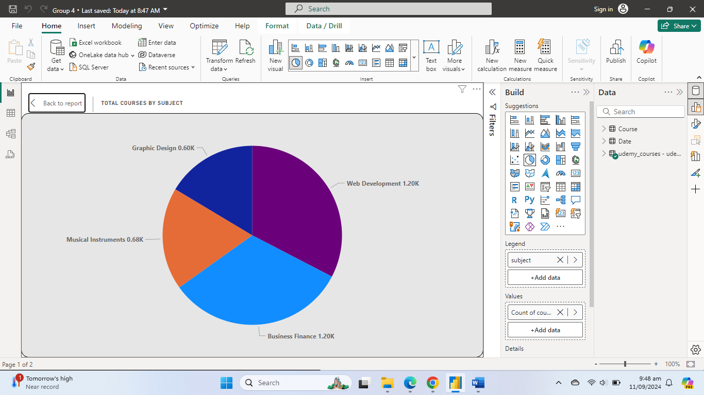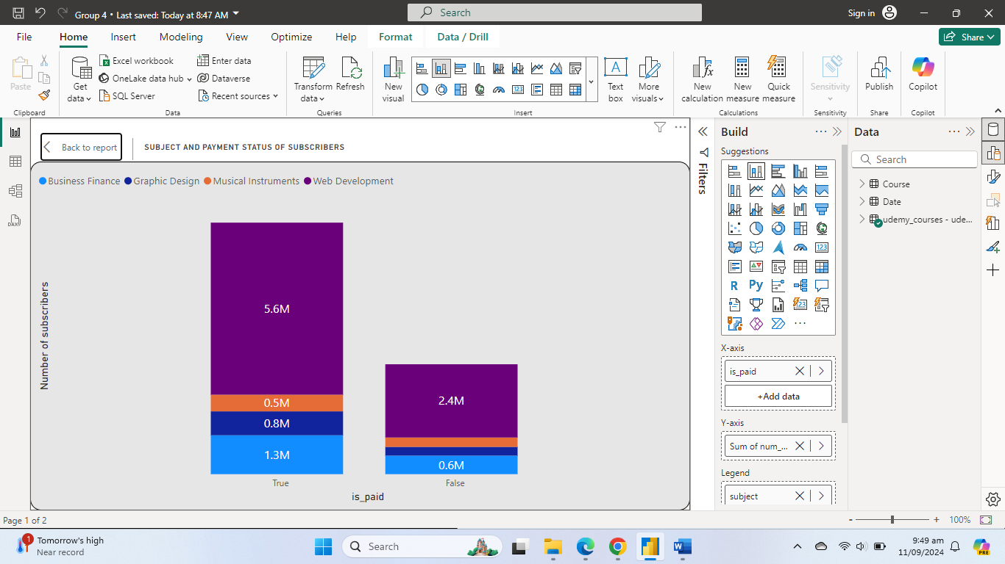

# Recommendations

1. Since paid courses attract a higher number of subscribers, it is important to explore some reasons why. Udemy could conduct a survey amongst subscribers, perform a course audit on both free and paid courses to find out features that free courses lack and how best to make them appealing to subscribers as well.

2. Our analysis shows Musical Instrument had the least popular among other subjects. Udemy should audit the courses under this subject to find out if it is really catering to the needs of the subscribers. Also marketing for the course should be intensified with some incentives to attract more subscribers. Marketing for the other subjects must also be intensified as the disparity is quite huge.

3. Overall, with a higher number of subscribers going through all levels is a positive look. The low record of subscribers who went through the Intermediate and Expert Level shows the advanced nature of the courses at this level and may suggest those courses might be very challenging. Udemy could create engaging pathways to encourage subscribers to progress to the next level. Also, incentives such as discounts could be offered to those who complete one level and move on to the next to improve on retention.

Additionally, collecting feedback from subscribers can help understand their expectations, preferences and challenges to guide course adjustments and improve on content quality.

4. Web Development is a major driver of Udemy’s revenue. To improve on the revenue from other subjects on Udemy, we could analyse the success factors that contribute to Web Development’s performance, such as if there were any promotions or discounts offered, average time spent on courses under Web Development, if the content is relevant and up to date and how easy it is to follow. Understanding these could help Udemy identify successful strategies and apply them to other subjects, potentially boosting its revenue in the long run.

# 5. Conclusion

Udemy's premium courses are more popular. Surveys and an audit of both premium and free courses would help Udemy make improvements by pointing out any features that are missing. Marketing efforts for other topics should be stepped up, and incentives should be made available to draw in more subscribers. Due to the difficult nature of the courses in the Intermediate and Expert Levels, Udemy ought to provide interesting development routes and rewards. Subscription feedback can help with content quality improvement and course changes. By examining success characteristics and applying them to other disciplines, web development—a significant source of revenue—can be made better.